Search Options

Search is an Opensim Viewer Feature. When enabled, a Destination Guide is available inside the viewer. The Search boxes are enabled in Settings-Search:
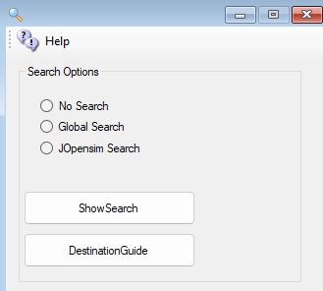
- JOpensim search only appears if you have installed Joomla and Jopensim.
- Global Search uses the Outworldz web site functions to search every DreamGrid, including yours.
- Show Search takes you to the Global Search engine.
- Destination Guide takes you to list of Grids that are online

Search Help
Search has built-in pattern matching for making string comparisons. The following table shows the wildcard characters you can use and the number of digits or strings they match.
WILDCARD CHARACTERS USED IN STRING COMPARISONS
Character(s) in pattern | Matches in expression
? | Any single character
* | Zero or more characters
# | Any single digit (09)
[ charlist ] | Any single character in charlist
[! charlist ] | Any single character not in charlist

Viewer Search
In each of the respective OpenSim viewers available, such as Firestorm, Singularity, etc... You have a Search feature. It might look like this inside each respective viewer:
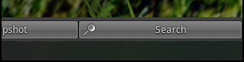
This brings up the following dialog with the respective search categories:
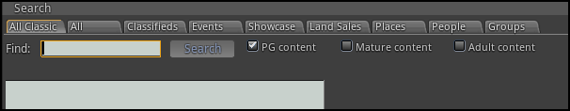

Enable Search
If enabled, any regions or prims marked in the viewer for Show In Search will be registered and indexed by the https://outworldz.com/Search server, and will available for anyone to look at. Turning off your system will remove it from search, as will unchecking this box.

Events
By just clicking on the Search button without specifying a search term you will see all events that are up and coming
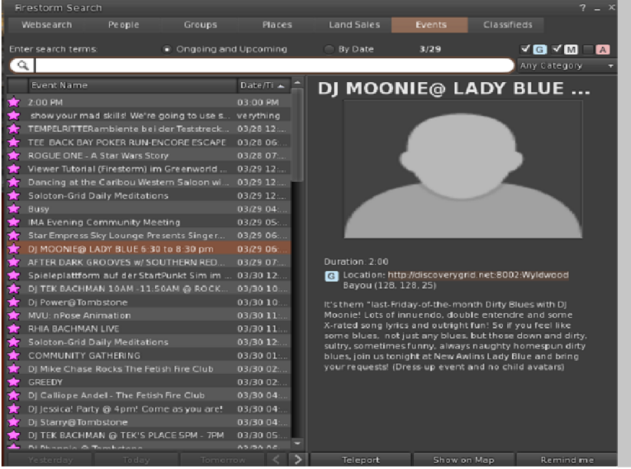

Search for Objects
This viewer screen lets you search for objects marked as “Show in Search”. There is a search button ‘magnifying glass’ at lower left to refine your search. You can select 100, 250, or 500 rows. You can sort by any column header by clicking the title.
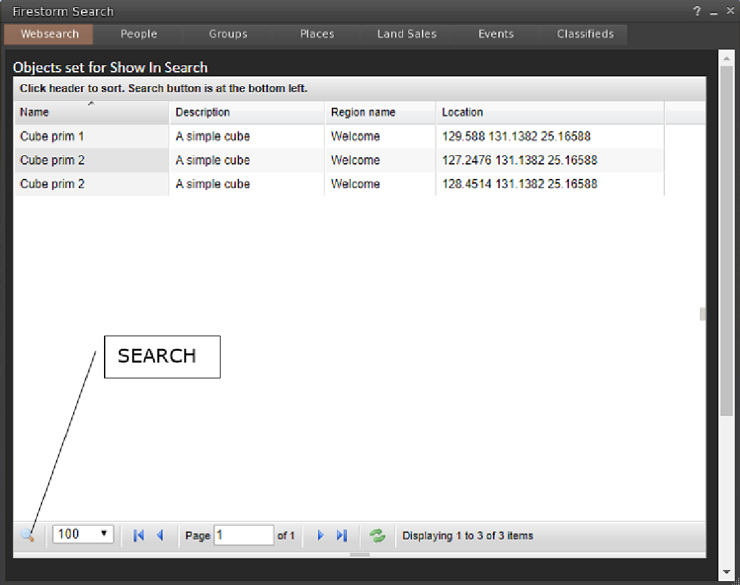

Places search:
Any parcel marked as “Show in Search” is located in this viewer screen.
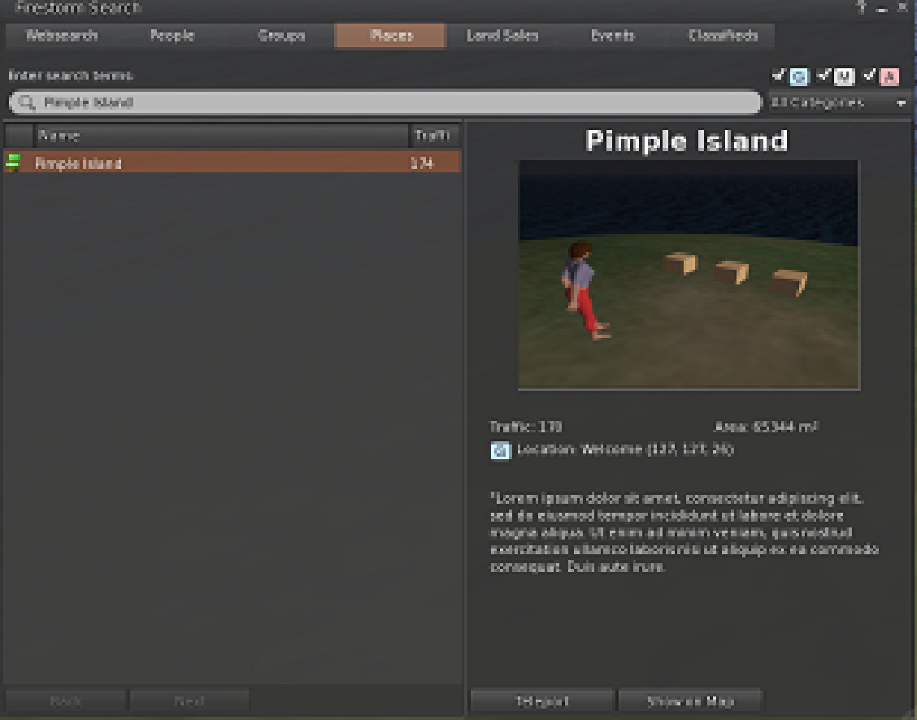

Land Sales:
Parcels marked for-sale and “Show in Search” can be located in this screen:
